

mark

**The Ministry of Education 20**

**The Education Directorate of---------**

**Second Exam- first Term**

**Class: fifth Grade**   **( (Action Pack 5**

**Language** **English**

**Date:**

**Name: ...................................................................................................................**

____________________________________________________________________________

**PART ONE**

Question One: Reading Comprehension:- (5 points)

-Read the following text **carefully** and then answer all the questions below

We arrived at the Royal Automobile Museum at five to ten. It's ten o'clock now and the museum is open. We're going to learn about the oldest cars and the oldest motorbikes. The oldest car is more than one hundred and twenty years old. The old motorbike is more than one hundred years old.

**1**1- When did they arrive to the museum?

.........................................................................................................................

2-What did they learn about?

.........................................................................................................................

3- the oldest car is more than:-

a- 120 years old b- 100 years old

4-Extract the following:-

A- Noun:-............................... B- Preposition: ............**.................**

**PART TWO:-**

Question Two: Focus on Vocabulary (5 points)

**A.** Look, read and choose: (2 points)

**1.** My brother is kind :-

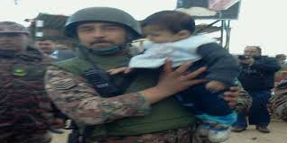 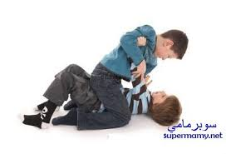 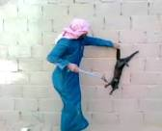

**a. b-. c.**

**2.** Old women sewed traditional costumes.

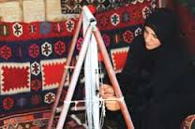  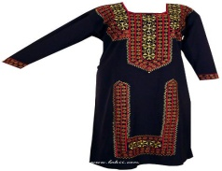

a-  **b- c-**

**B.** Read and complete:

(3 points)

evening - morning - Collection - motorbikes

1. The museum opens in the ………………………………………

2We,re going to learn about the oldest cars in the…………………………….

3. You can see ……………………… the museum.

**PART THREE**

Question Three: Focus on Language and Structures (5 points)

**A.** 1- Complete the following comparative sentence :- ( 2 marks)

A- Ali is .......................................... Ahmad. ( tall)

B- Gold is ..................................... silver. ( expensive)

2- Correct the verbs between brackets:-(3 marks)**:**

A- She .......................... Aqaba next weekend.(go)

B- ........... you........... to Petra last year? (go)

C-He .............. football every week. ( play)

**B.** 1-**Write the correct time in front of each picture(3points)**

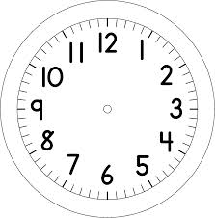





Question Four: Focus on (2 points)

**A.** Write about yourself:- (3 points)

1- What are you going to do ?

--------------------------------------------------------------------

2-What was your favourite day in the holiday?

---------------------------------------------------------------

THE END