

mark

**The Ministry of Education 20**

**The Education Directorate of---------**

**Second Exam first Term**

**Class: Fourth Grade**   **(Action Pack 4)** **Language** **English**

**Date:**

**Name: ...................................................................................................................**

_________________________________________________________________________________________

**PART ONE**

Question One: Reading Comprehension (5 points)

-Read the following text **carefully** and then answer all the questions below:

**Dear Grandpa and Grandma,**

**We're in Aqapa! We're staying in a hotel by the sea. We're at the Marine Park on the beach. We aren't swimming. We're looking at the fish and the turtle. The turtle isn't swimming. It's sleeping! Mum is buying some postcards.**

**Samira and Kareem**

1. -Where are Samira and Kareem? ( **1point**)

………………………………………………………………………………….

2-What are Samira and Kareem looking at? ( **1point**)

…………………………………………………………………………………..

( **1point**) 3-Where are they stay?

............................................................................................................................

4-4-Find out:-( **2point**)

A-Noun:- ...............................

B-Preposition:- ...................

**PART TWO**

Question Two: Focus on Vocabulary (5 points)

**1-Look and write :-(2point)**

**visiting the waterfalls – going to Aqapa – swimming in the warm water**

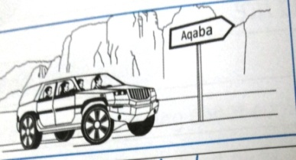

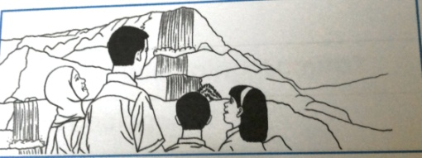

**B.** Read and complete: (3 points)

- use - swimming - warm cold

1. The water is……………………………………… in Hammamat Ma'in.

2. Kareem is good at………………………………………………...

3. Kareem and Samira can……………………………………….computer.

**PART THREE**

Question Three: Focus on Language and Structures (7 points)

**A.** Choose the correct answer in the following sentences: (3 points)

1-She never ................ in the library.

a- talk b- talks c- talking

2-I am going to .....................a farm next week

. a-visit b- visits c- visiting

3-They are ................. now.

a- eat b- eating c- ate

**B- Look and answer: (2 pts)**

**1. Is Kareem's father playing tennis?**

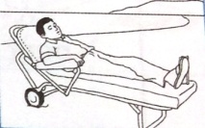

**………………………………………………………………………………………………………….**

2- Is **Grandma reading a postcard?**

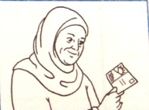…………………………………………………….

C**--Order the following sentence:- (2 marks)**

1-is / subject / Arabic. / favourite / My-..............................................................................................................................

**2-they/a book/are/ reading**

**………………………………………………………………………………………………………………**

**ART FOUR**

Question Four: Focus on Writing (3 points)

**3) Copy and complete with the punctuation: (capitals, . or ?):**

**1. issa is helping mum**

**2.is she doing a project about amman**

**2) Order the sentences: (2 pts)**

THE END WITH MY BEST WISHES