|  |
| --- |
|  |
| **25** |

Class: 1st Grade Date:

Name:………………………… Time: 35 Minutes

***Q1: Read and Match( 2 points )***

1. What’s your name? A. It’s a clock.
2. What’s this? B. I’m Samira.
3. How are you? C. It’s white.
4. What colour is it? D. I’m very well thank you.

***Q2: Match objects with their names.( 6 points )***

1.door 2. Window 3. Chair 4. Pencil5. Robot 6. Bag



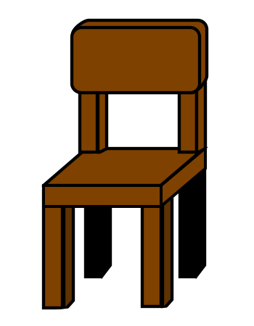



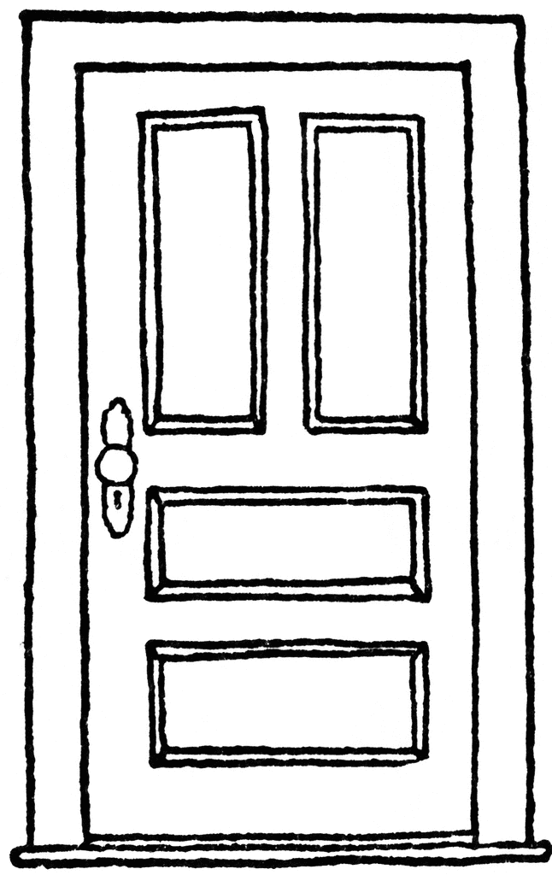





**Q3: Look and circle( 3 points )**





1. This is a book a**.b.**





1. **Three birds a. b.**

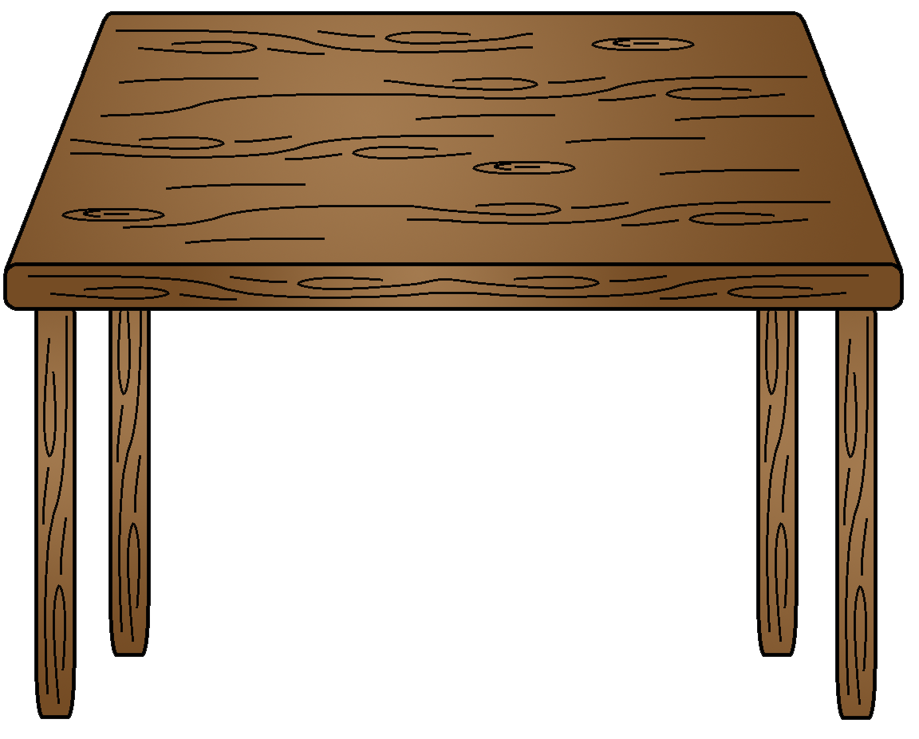

1. **This is a table a. b.**

**Q4: Count ( 5 points )**

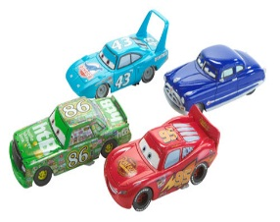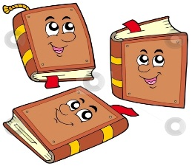

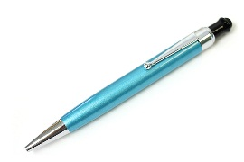

**Q5: Listen and color ( 3 points )**



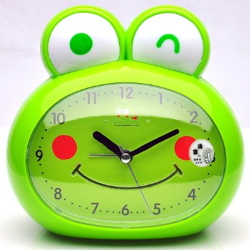

**Q6: Write the letters ( 6 points )**

|  |  |  |  |  |  |  |  |  |  |  |
| --- | --- | --- | --- | --- | --- | --- | --- | --- | --- | --- |
| **A** |  | **C** | **D** |  |  | **G** | **H** |  |  | **K** |
|  | **b** |  |  | **e** | **f** |  |  | **i** | **j** |  |

**Best Wishes**

**☺T. Fatima Ramadan**