

**The Ministry of Education**

**The Education Directorate of /**

**……………………… School**

**Final Exam- First Term**

**Name: ____________**

**Class: 3rd grade Date................**

*-----------------------------------------------------------------------------------------*

Question number 1: Read and answer  **(5 points)**

We are in Canada. It is winter. It is cold and snowy today. My brother goes I ice-skating. My sister is making a snowman. Dad is helping her. Mum is taking a photo.

1. Where are they?______________________
2. What season is it? ____________________

3. Who is making a snowman? ____________________________ .

4. Mum is taking a photo. ( T - F )

5. It is hot and windy. ( T - F )

Question number 2: Fill in the blanks : **(6 points)**

**email/ setting */restaurant / photo / What / delicious***

1. Asma is writing an ___________.
2. _________would you like?
3. This salad is________________.
4. Mohammad is taking a _____________.
5. My father is a chef. He works in a _________________.
6. Ziad is______­­­________the table.

**Question number 3: Look, read and Match (5 points)**

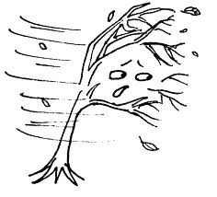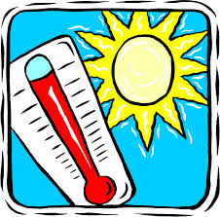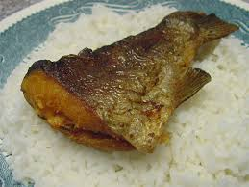

**( rainy - aubergine - fish and rice - hot and sunny - windy )**

**Question number 4: Circle the correct answer:** **(4 points)**

**1. They _____at home. (are – is- am)**

**2. Is it cold and snowy? No, it_______. (isn't – aren't- doesn't)**

**3. My book is ________my bag. (on – under – in )**

**4. I am ________a basketball. (playing- reading- eating)**

**Question number 5: Copy this sentence correctly:**  (2 points)

1. **Dad is driving his car.**

____________________________________________________

____________________________________________________

. ____________________________________________________

____________________________________________________

**Question number 6: Order the sentence. (2points)**

**Taking / I/ am /photo/a ­­­­­­­­­­­­­­­­­­­­­ ______________________________**

**Question 7: Odd the one out! (1 points)**

1. **rice – meat - computer - aubergines**
2. **winter – sunny – spring – summer – autumn**

***************************************************************************************************************************

THE END

WITH MY BEST WISHES