 mark

**404 40**

**The Ministry of Education**

**The Education Directorate of---------**

**Final Exam- Second Term**

**Class: 5Th Grade**   **(Action Pack 5)**  **Material: English Language**

**Date: - \\2022**

**Name: ....................................................................................................... .Section ( )**

_________________________________________________________________________________________

**QUESTION ONE : *Reading: (8Points):-***

**A: Read the following text and answer the following questions. (8 marks):-**

**Mustafa Salameh worked in a hotel for ten years. He liked climbing . He said, I think that I will c climb the highest mountain on Earth .**

**On Independence Day 2008, Mustafa put the Jordanian flag on the highest mountain. . There were celebrations in Jordan.**

**1-Who is Mustafa Salameh?**

**2- where did he work?**

**3- Why were celebrations in Jordan in 2008?**

**4- Find in the text a word opposite to lowest..**

**5- What does the underlined pronoun refer to :.............................................................................**

**6- Where will you travel when you grow up?**

**7- What did Mustafa Salameh like?**

**8- Do you like climbing a mountain?**

**QUESTION TWO :  *Speaking:- ( 12 Points):***

**Q1: Complete the sentences with words from the box. (6 points) *:-***

**Taste  fireworks - Independence Day - skyscrapers – astronauts- project**

1- Jordanian people enjoyed ---------------.

2- ------------- will discover new planet.

3- Bananas------------delicious.

4-In twenty years, I think that people will live in --------------.

5-There were some colourful---------------- at night.

6- She's got a---------------- for school.

**Q2: Look at the pictures and answer the questions: (6 points):-**

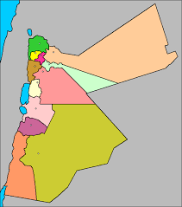

**a- Amman is in the.**

**b- Aqaba is in the.. .**

**c- Irbid is in the.**

**d- The Dead Sea is in the ..**

**QUESTION THREE:- *Writing:- (12 Points)***

Choose the correct answer:- **1**

**1. I have never..to India. A- be b- been c- am**

**2. You read your book a- usually b- always c- never**

**3. I've already clean.my room. a. ing b. s c. ed**

**4- Have youvisited Petra? a- ever b- be c- always**

**5- We .. watch a lot of television a- should b- shouldnt c- always**

**6- We play a lot of sport .., we are strong. a- because b- so c-?**

**A- Choose the correct punctuation:**

**1. Have you ever swum in the sea a- ? b- ! c- .**

**2. I've never seen Arabian Oryx.. a- . b- ? c- ,**

**B- Oder and Write:**

**1)- Everybody \ smiling. \ is**

**2- breakfast /am / I / had /a / not / hungry / I / big / because /**

**.**

**C-: Write a sentence about each picture.(2 points):-**

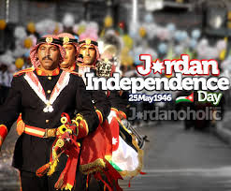 

**QUESTION FOUR:- *Listening (8 Points)***

**Q1:: Listen and choose the word you hear.( 2 points ):-**

1. **airport autumn board Jordan**
2. **bronze desert fizzy zoo**

**Q2: :** **Listen and match( 6 points ):-**

**Teacher thinks that**

1-Omar will be a.

2- Nada will be a

3- Ahmed will be a ..

4- Ali will be a

a- b-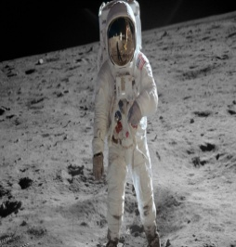

j0186348 d- j0233312 -cc