فففغفغفغفغفغفغففففغفغلللل

School : Amir Hassan Prep. Boys / 2

English second Exam / Second Semester

**Name    : ----------------------------- Class : 2 nd (        )**

**-----------------------------------------------------------------------------------------------**

**QUESTION ONE** *Listen and draw the time*    ( **2   marks** )

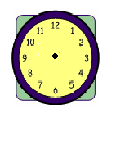

***-----------------------------------------------------***

**QUESTION TWO *look and match ( 5 marks )***

|  |  |  |  |  |
| --- | --- | --- | --- | --- |
| ***pyjamas*** | ***watch*** | ***fig*** | ***Sunglasses*** | ***present*** |

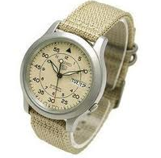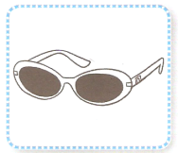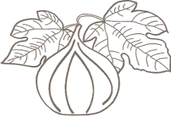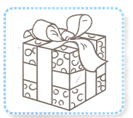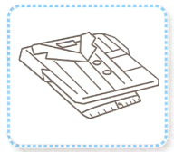

--------------- -------------- -------------- -------------- --------------

***--------------------------------------------------***

**QUESTION THREE write the missing letter   ( 4 marks  )**

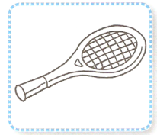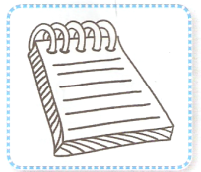

***----otebook     tennis rac----uet***

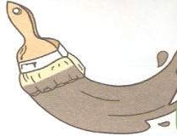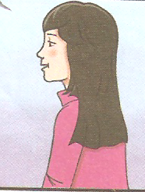

***---ong ----rey***

***-----------------------------------------------------***

**QUESTION FOUR  Answer the questions ( 2 marks )**

**1 -  What's your name ? -------------------------------------------**

**2 -  What do you look like ?**

**---------------------------------------------**

**---------------------------------------------**

**---------------------------------------------**

**QUESTION FIVE  Look and circle ) 4 marks )**

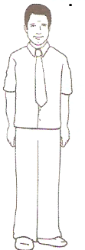

**He's  tall  /  short**

**He's got short  /  long black hair**

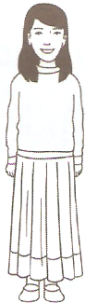

**She's  tall   /  short**

**She's got  long /  short black hair**

***-----------------------------------------------------***

**QUESTION SIX  *Match capital with small letter* ( 4 points )**

**M T A O G Q E Z**

**t m o a q g z e**

**Good Luck**

**English teacher Emad Ahmad**gg SSsslklklklklhjhjhغففففغفغلللل