Class:2nd grade Department of Education Section:

Name: Mark: /20

Diagnostic Test

Reading: <9 Marks> 

A) Read and answer: <3 Marks>

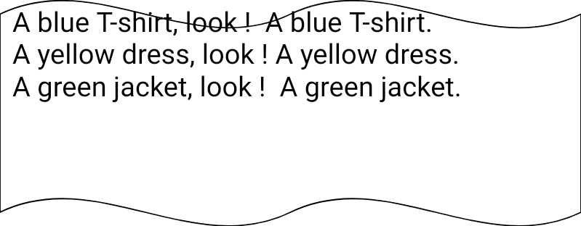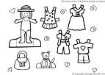

1. What's the color of the dress ?....................................................................

2. What's the color of the T-shirt?...................................................................

3. What's the color of the jacket?.....................................................................

B) Read and circle : < 4 Marks >

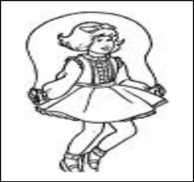

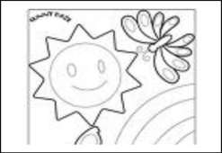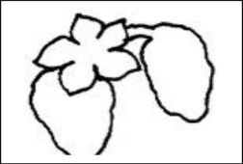

red hop dates windy

rabbit skip apples sunny

rainbow jump bananas rainy

C) Read and match:< 2 grades >



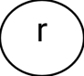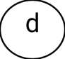

[Writing: < 7 Marks >](http://www.google.jo/imgres?imgurl=http://www.craftelf.com/Coloring%2520Pictures/Free%2520school%2520coloring%2520pages%2520for%2520kids%2520Pencil%2520man.gif&imgrefurl=http://www.craftelf.com/Craft_elf_School_Music_coloring_pages.htm&usg=__cNFg6FMwyXQynhnQvfxFzb-TM40=&h=1540&w=1091&sz=20&hl=ar&start=21&itbs=1&tbnid=g7FHiLgHrUrQdM:&tbnh=150&tbnw=106&prev=/images%3Fq%3Dcolouring%2Bpages%2Bfor%2Bkids%26start%3D18%26hl%3Dar%26sa%3DN%26gbv%3D2%26ndsp%3D18%26tbs%3Disch:1)

A) Match each part of the body with its name: < 3 Marks >

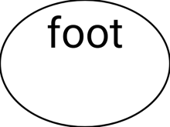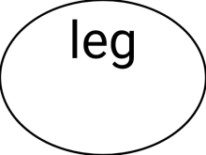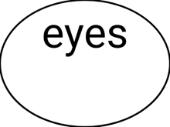  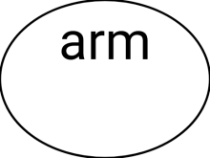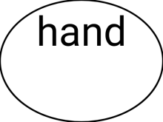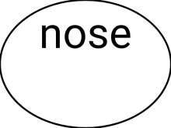

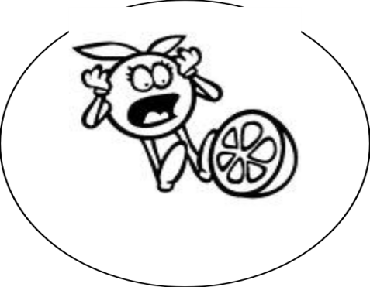

B) Write the sentences correctly : < 2 Marks >

1. ( oranges – like – I )

I ……………………………… .

2. ( I've – hair – got – brown )

I've………………………………

C) Copy the letters correctly: < 2 Marks >

B b D d E e G g





[Speaking: < 4 Marks >](http://www.google.jo/imgres?imgurl=http://www.k-state.com/%257Bdyn.img%257D/2ada4f0fe9264e788c958f41b70a8356/Coloring%2520page:%2520Born%2520to%2520be%2520a%2520Wildcat%2520-%2520What&imgrefurl=http://munkeyflora.blogspot.com/2007_11_01_archive.html&usg=__EaTOQtwrjcWQezAExMvqmIr0B9c=&h=388&w=300&sz=128&hl=ar&start=55&itbs=1&tbnid=PJgQk0-gNF1W9M:&tbnh=123&tbnw=95&prev=/images%3Fq%3Dcoloring%2Bpictures%2Bfor%2Bshouting%26start%3D54%26hl%3Dar%26sa%3DN%26gbv%3D2%26ndsp%3D18%26tbs%3Disch:1)

[A) Answer the following questions :](http://www.google.jo/imgres?imgurl=http://www.k-state.com/%257Bdyn.img%257D/2ada4f0fe9264e788c958f41b70a8356/Coloring%2520page:%2520Born%2520to%2520be%2520a%2520Wildcat%2520-%2520What&imgrefurl=http://munkeyflora.blogspot.com/2007_11_01_archive.html&usg=__EaTOQtwrjcWQezAExMvqmIr0B9c=&h=388&w=300&sz=128&hl=ar&start=55&itbs=1&tbnid=PJgQk0-gNF1W9M:&tbnh=123&tbnw=95&prev=/images%3Fq%3Dcoloring%2Bpictures%2Bfor%2Bshouting%26start%3D54%26hl%3Dar%26sa%3DN%26gbv%3D2%26ndsp%3D18%26tbs%3Disch:1)

What is your name?

How old are byou?

B) Match :

a. I'm Suha 1 How many cats ?.......

2. What's your name?......... b. It's a fox

c. two cats

GOOD LUCK