

**The Ministry of Education**

**The Education Directorate of ------------**

**Final Exam- Second Term**

**2021/2022**

**Class: Third Grade**   **(Action Pack 3)** **Material: English Language**

**Date:**

**Time: One hour.**

**Name: .......................................................................................................................................Section :(..................)**

**PART ONE**

Question One**:** Reading Comprehension (7.5 points)

-Read the following text **carefully** and then answer all the questions below:

I want to make presents for my family !For my mum, I want to make a card . She likes flowers. I want to draw some flowers on her cards. For my dad I want to make a notebook .He likes writing. For my brother I want to make a ball. And for my grandma and grandpa I want to draw a picture of our family.

Sami

**1.** Mum likes---------- a. writing b. flowers c. pictures (1 points)

**2.** Who wants to make presents? (1 points)

..

**3.**Mention three things he wants to make ? (2.5 points)

a-b-c-.

**4.** When is mother's day : a. 21st March b. 5th October c. 25th May (2 points)

**5.** Draw a present for your mum? (1points)

Question Two: Focus on Vocabulary (7.5 points)

**A.** Look, match and write: (2.5 points)

Owl perfume scarf chemist's Independence Day butcher's

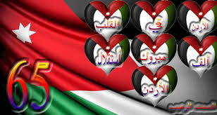 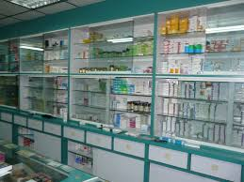

------------------- -------------------

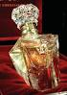

-------------------

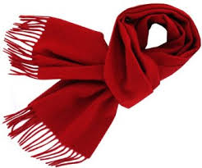 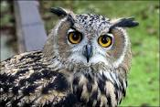

------------------ ------------------

**B. Read and complete the sentences:**  (5 points)

healthy opposite, fruit ice- cream museum an eagle,

1. ----------**----** is goodfor me **.**

2. Vegetables are --------------- **.**

3. The bookshop is-------------- the post office**.**

4. --------------lives in Wadi Mujib **.**

5. There is a big ----------------in my city.

**PART THREE**

Question Three: Focus on Language and Structures (7.5 points)

**A.** Choose the correct answer in the following sentences: (5 points)

1. You ---------listen to your teacher. a. must b. mustnt c. ?

2. June, July,----------- , September. a. October b. November c. August

3. ------------- any trees in the park? a.Is there b. Are there c. ?

4. ------- forget your books. a. Doesn't b. Don't c. Aren't

5.There-------- leopards in the zoo**.** a. are b. is c. does

**B.** Read and rewrite (**V-ing**) (2,5 points)

1. The goats / are / eat.

..

2. The cat /is/ climb.

.

3. I /am/do / my homework.

.

**PART FOUR**

Question Four: Focus on Writing (2.5 points)

**A**. Choose the correct punctuations in the following sentences: (1.5 points)

1. What's the weather like in Jordan a. **?** b. **.** c. **!**

2. Wolves live in the mountain a. **?** b. **.** c. **'**

3. No...I've never visited Wadi Mujib . a. **?**  b. **'** c. **,**

**B.** Order and write: (1 points)

1) –the cat/looking /is/ziad/at.

..

2) – wants /Asma /a present/to/buy

.