

**The Ministry of Education**

**The Education Directorate of**

**School---------------------**

**Final Exam- Second Term**

**Class: Fourth Grade**   **(Action Pack 4)** **Material: English Language**

**Instructor: Date: \ \2022**

**Time: One hour. أجب عن جميع الأسئلة المذكورة**

**Name: .......................................................................................................................................Section :(..................)**

**PART ONE**

Question One**:** Reading Comprehension (10 points)

-Read the following text **carefully** and then answer all the questions below:

**We must plant more trees .Trees are very important .Trees are home for many animals and birds .They give us shade in the summer . They clean the air Trees give us wood and paper**

**Every year on 15th January children plant trees. It is an- important day. We sing song, we take photos, and make videos. We watch the trees grow.**

1. **Are trees important?---------------------------------------------------------------------------------------------------------------------------------------------------------------------------------**
2. **Where do many animals and birds live?---------------------------------------------------------------------------------------------------------------------------**
3. **How do trees help us when it is hot?-------------------------------------------------------------------------------------------------------------------------------**
4. **What trees give us?**
5. **-------------------------------------------------------------------------------------------------------------------------------**

**5- What happens on 15th January ?------------------------------------------------------------------------------------------------------------------------------------------------------------------------------------**

**PART TWO**

Question Two: Focus on Vocabulary (9 points)

a- Read and complete the sentences: (5 points)

**Bridges - old - birds - big - Madaba**

1- **Last week Kareem and Samira went to---------------.**

**2- The map is very-----------------and very------------.**

**3- They saw----------------over the Jordan River.**

**4- Kareem and Samira saw ----------------and animals on the mosaic.**

Question Three

**B.** **Order tips of planting a tree: (4 points.)**

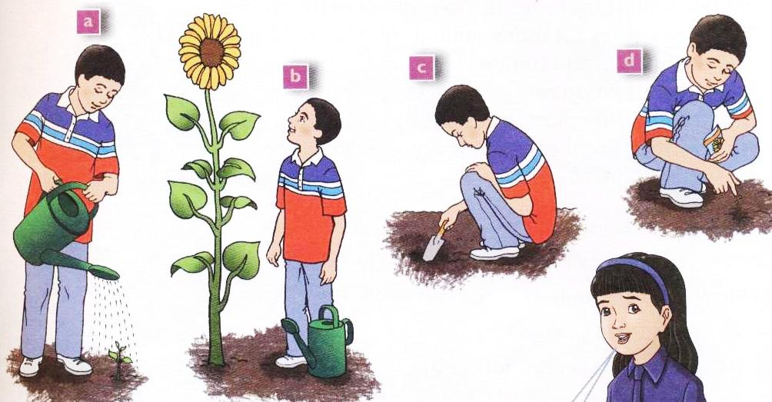

1. ______ You must dig a hole.
2. ______ Put a seed into the whole.
3. ______ You must water it every day.
4. ______ Wait for the flower to grow.

**PART THREE**

Question Four: Focus on Language and Structures (10points)

**a--Choose the answer from those given to complete each (10 points):-**

**1- Jupiter is the ----------planets.**

**a-biggest b- smallest c- bigger**

## 2The planetarium is the------------room in the museum.

## a-biggest b- darker c- darkest

## 3- ----------can you see in the museum?

## a-when b- what c- where

## 4- - -----------is your brother?

**a-who b- when c-what**

## 5- ----------do you live?

**a-what b- where c- when**

## 6- Yesterday I ------------the library.

**a-visit b- visiting c-visited**

## 7- I didn't ----------football last Friday.

## a-play b- played c- playing

## -8- Ali is the----------------pupil in the class.

**a- tall b- taller c- tallest**

**9-What ---------------you do yesterday**

**a- do b- did c- does**

**10- Kareem------------------------an old coin**

**a-find b- found c- founding**

**b- Complete the table: (4 pts.)**

|  |  |
| --- | --- |
| Present | past |
| find |  |
|  | bought |
|  | saw |
|  |  |

Question Five **-** **Match sentences with the pictures: (2 pts)**

Went to the museum - **had / meal / restaurant**

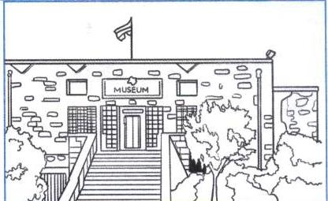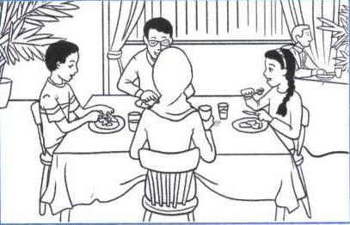

|  |
| --- |
|  |
|  |
|  |

|  |
| --- |
|  |
|  |
|  |

Question Six **a--Complete please:- (2points)**

**Ph wr kn**

**1- ele-------ant.**

**2-------ite.**

**3--------ee .**

**4--------one.**

**b- -Answer the following questions :- (3 points)**

**1- What is you name?**

**.**

**2- Where do you live?**

**.**

**3- How do you come to school?**

THE END

WITH MY BEST WISHES