**English language Exam**

**Second Semester/Second Exam**

**Class: 5TH grade Name----------------------**

**Reading: Read the following text carefully :** [](https://www.google.jo/url?sa=i&rct=j&q=&esrc=s&source=images&cd=&cad=rja&uact=8&ved=0ahUKEwikuNrsw_bLAhVG7xQKHRq9BDwQjRwIBw&url=https%3A%2F%2Fwww.assawsana.com%2Fportal%2Fpages.php%3Fnewsid%3D217951&psig=AFQjCNFwOhzgqKBGrJYfCHoV33tukF7I2A&ust=1459912454236863) 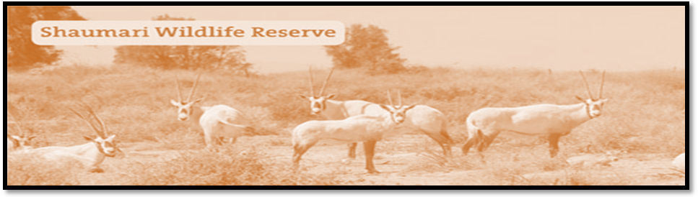

**I took this photo from the top of the tower at the Shaumari Reserve in Jordan the you can see Jordan’s national animals, the Arabian oryxes, *they* are safe now because the live at the nature reserve.**

**The national colours of Jordan flag are red, black, white and green. These colours show the past of our country.**

**1-Where is Shaumari Reserve situated?------------------------------------------------------------**

**2-What can you see in Shaumari Reserve?--------------------------------------------------------**

**3-why do Arabian Oryxes safe now? ---------------------------------------------------------------**

**4-The Arabian Oryx is our national animal. (T F)**

**5- There are many colours in the Jordanian flag . mention to them**

**-----------------------------,------------------------------,-----------------------and---------------------------.**

**6- The under lined pronoun (*they* ) refers to----------------------------------------**

**7- Find word from the first paragraph which means ( *watch*)-------------------------**

**8- Critical thinking: Do you like to visit Shaumari Reserve? Why/ or why not?**

**-------------------------------------------------------------------------------------------------------------------**

**2-Choose the correct word to complete the sentences:**

**( market , Arabian Oryx , play , important )**

**1-Good health is very---------------------------------**

**2-Iam going to the ----------------------------- to buy some tomatoes.**

**3- ---------------------------- is Jordan national animal.**

**4 - Sami go to the sport center to ------------------- tennis .**

**3- What does this sentence mean in the following?**

**Students *should* study hard about their exams ---------------**

**4-Choose the suitable item to complete of the following sentences:-**

**1- You ---------------go to bed early. (should / shouldn’t )**

**2- you --------------eat sweets. (should / shouldn’t**

**3- you shouldn’t shout. (Yes / No)**

**4- you should drink a lot of water. (Yes / No)**

**5- You study hard---------------- you success. ( so / because)**

**6- We speak Arabic -------------- we are from Jordan. ( so / because)**

**5- Read and order:-**

**1- happy/ on holiday/ he’s/ because/ jabber/ is .**

**2- go/we /learn / a lot / we /to school/ we /so**

**............................................................................................................................................**

**6- Correct the underlined words.**

|  |
| --- |
| **rand should playing sport every day and he doesn’t like fizy drink .** |

**7- Talk about you:**

**1-I--------------------------------------------------------------so------------------------------------------------**

**2-I-------------------------------------------------------because----------------------------------------------**

**8- write a short paragraph about :**

1. **a trip you are going to go with your family to the Nature Reserve.**

**B – describe how to make bread and meat arayes.**

***Good luck: Rania Ahmad***