**The Ministry of Education**

**The Education Directorate of /**

**……………………… School**

**Final Exam- First Term**

**Class: First Grade**   **Material: English Language**

**(Action Pack 1)**

**Date: ………..**

**Time: One hour.**

**CACLIBWX Name: ....................................................................................................Section ( )**

***Q1 Fill in the blanks:-( 4 marks )***

**sister - Hello - red - Dad**

APPLE1- It's a \_\_\_\_\_\_\_\_\_\_\_\_an apple.

D:\New Folder\New\guy2.gif

2- This is my \_\_\_\_\_\_\_\_\_\_\_\_ .

05

I'm Sami.

3- \_\_\_\_\_\_\_\_\_\_\_! I'm Sami .

girl519di

4- Dana is my \_\_\_\_\_\_\_\_\_\_\_.

I'm Dana.

CACLIBWX***Q2 Write the correct colour under each picture:-(3 marks)***

yellow

red

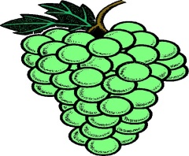

green

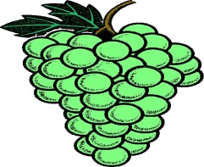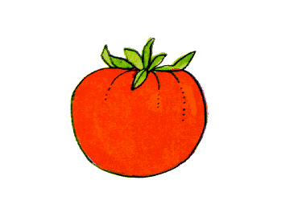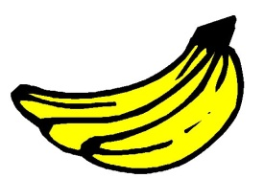

----------------------------- --------------------------- ---------------------------------

CACLIBWX\*\*\*\*\*\*\*\*\*\*\*\*\*\*\*\*\*\*\*\*\*\*\*\*\*\*\*\*\*\*\*\*\*\*\*\*\*\*\*\*\*\*\*\*\*\*\*\*\*\*\*\*\*\*\*\*\*\*\*\*\*\*\*\*\*\*\*\*\*

***Q3 Write the missing letters :-( 3 marks )***

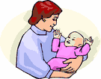

\_\_\_\_ rother M\_\_\_m

CACLIBWX

***Q4 Choose and circle the missing letters :-( 3 marks***

******

1) bo\_\_\_\_ **( s - x )**



2) **pe\_\_\_( n - m )**

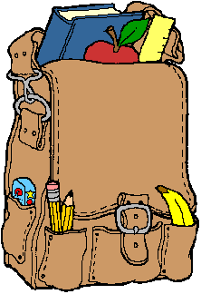

3) ba \_\_ **( g- j )**

***CACLIBWXQ5 Circle words that don't have the same rhyme:-( 3 marks)***

er_a03

lap - ball - hat - bat

er_b01

man - bag - dog - fan

er_c03

cat - tack - jack - back

CACLIBWX\*\*\*\*\*\*\*\*\*\*\*\*\*\*\*\*\*\*\*\*\*\*\*\*\*\*\*\*\*\*\*\*\*\*\*\*\*\*\*\*\*\*\*\*\*\*\*\*\*\*\*\*\*\*\*\*\*\*\*\*\*

***Q6 Match then write the numbers:-( 6 marks )***

How are you? you you

1- Oh! Thank you !

I'm fine, thank you.

Hello!

2-

This is for YOU

Hello!

3-

***CACLIBWX Q7 Copy the following word on lines correctly:-( 3marks)***

**Blue**

G0122856G0122856G0122856G0122856

G0122856

G0122690T

THE END WITH MY BEST WISHES

