

Directorate of Education/

-------------------------

English language

2015/2016

Class:2nd Grade

Date:- Name:-

Q1) Complete these sentences with the missing words (7 points)



***Word bank***

lion- elephant – swim – tiger – monkey – fly - bear

1-A……………can climb a tree.

2-A……………….can jump.

3- A turtle can …………..in the water.

4-A……………….can eat the man.

5-An ……………….can swing its long nose.

6-A ………………can run very fast.

7-The birds can ………………..

**Q2Answer please**: (10 points)

1. I live in………………..



1. **Asma lives in………...**

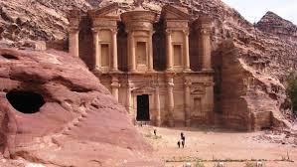

3-Mazen lives in................



4-Grandparents live in.....................



5-Ali lives in.......................

**Q 3Copy:-** (2 points)

1. **Is it agirl?**

|  |
| --- |
|  |
|  |
|  |

1. What is the matter Asma.

|  |
| --- |
|  |
|  |
|  |

**Q4 Choose the correct answer please:** (5 points)

1. Today is............
2. Sunday b- Monday c- Tuesday
3. Oh my head ,I’ve got ..........

a- Ahead ache b- earache c- stomachache

3-Eleaphants are.......................

a- small b- big c- fast

4-Ababy can.......................

a- fly b- swim c- walk

5-I,m ill you must go to the.................

1. doctor b- school c- dentist

**Q5 Draw your favourite animal?** (1 point)

WITH MY BEST WISHES

j0281904TEACHER :