

**25**

School : Amir Hassan Prep. Boys / 2

English second Exam / Second Semester

**Name : ---------------------------------------- Class: 1st**

**----------------------------------------------------------------------------------------------------------------------------**

**UESTION ONE *Listen and colour*  3 marks**

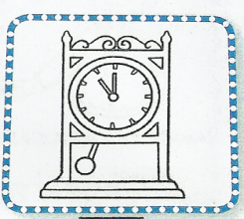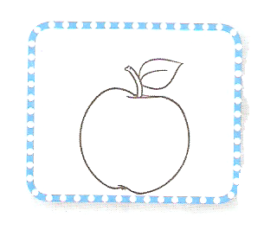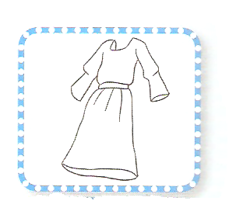

**QUESTION TWO *Write the numbers* 5 marks**

***-----------------------------------------------------------------------***

|  |  |  |  |  |  |  |  |  |  |
| --- | --- | --- | --- | --- | --- | --- | --- | --- | --- |
|  |  |  |  |  |  |  |  |  |  |

**QUESTION THREE Write the missing letters ( 4 marks )**

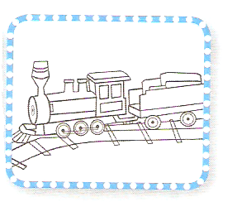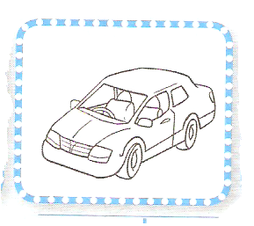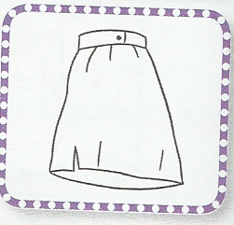s p t c

**---ar ---kirt ---en -----rain**

***-----------------------------------------------------------------------***

|  |  |  |  |  |
| --- | --- | --- | --- | --- |
| **ride a bike** | **run** | **hop** | **swim** | **jump** |

**QUESTION FOUR *Look read and write (5 marks )***

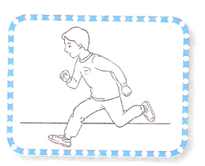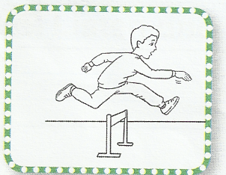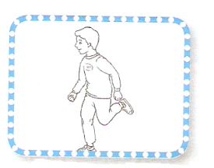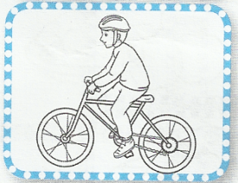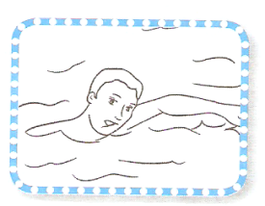

**-------- ------- ----------- ------ --------**

**QUESTION FIVE  *count and write the number* ( 4 marks )**

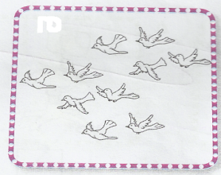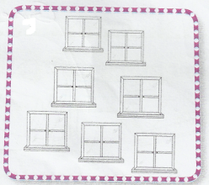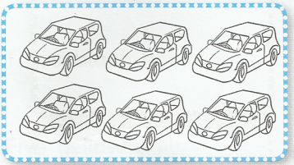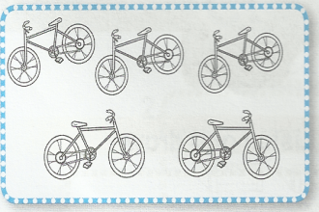

***-----------------------------------------------------------------------***

**QUESTION SIX  *Match capital with small letter* ( 4 points )**

**R H S D F Y G Z**

**h r d s y f z g**

Good Luck

Teacher Emad Sbeihat