TheHashemiteKingdomofJordanMinistryofEducation

25

Thefirstsemesterexamoftheyear2016/2017

Al-Nahdhaschool Subject:English

Class:Grade2 Time:Onehour

Student'sname..……………………................... Date………./ /2017

Mentionthenameofeachselectedanimal:(3marks)

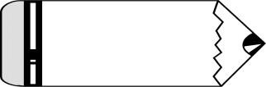

# tiger



elephant



lion



bear

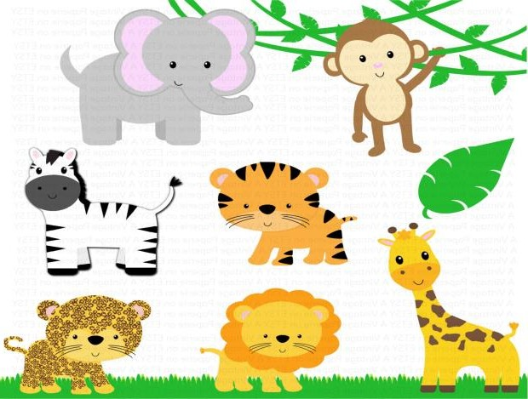

elephant

tiger

lion

A:Completethegapswiththecorrectdayoftheweek:(4marks)

|  |  |  |  |  |
| --- | --- | --- | --- | --- |
| Sunday | Monday | Tuesday | Wednesday | Thursday |
| Friday | Saturday |  |  |  |

B:Match each expressionwiththecorrectpicture:(3marks)

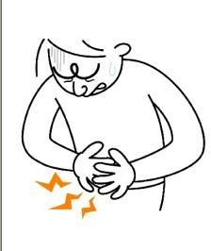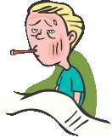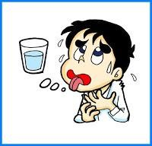

I'mthirsty I'mill I'vegotastomachache

1

Fillintheblankswiththecorrectadjectives:(3marks)



old



young



big

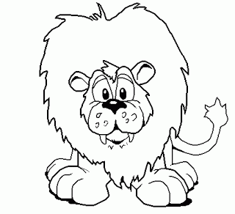 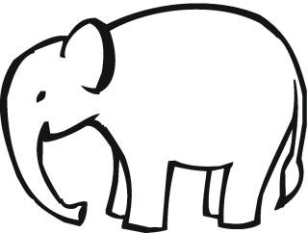 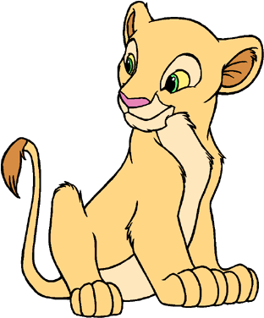

old big young

B:Reorderthefollowingletterstoformmeaningfulwords:(2marks)

eadhheca headache

ooachtthe toothache

Choosethecorrectanswerbetweenthebrackets:(4marks)

1. Can**they**…………..?(**swim**/**swims**)
2. Wheredo**you**…………..?(**lives**/**live**)
3. **She**………….inAmman.(**live**/**lives**)
4. …………...**you**gotastomachache?(**Has**/**Have**)

Circlethecorrectanswer:(6marks)

1. **Is**itapark?Yes,it……..
   1. is b.was c.Is
2. **She** anearache.
   1. havegot b.hasget c.hasgot3.No,they…………..

a.can b.could c.can't

1. **Is**itapark?Yes,………...
   1. is b.isit c. itis
2. doesyourmotherlive?
   1. Where b.Do c. Does
3. bear**s**.

# They're b.It's c.Isit

2

TEACHER: ALA’TWAIT