



mark

**The Ministry of Education 20**

**The Education Directorate of---------**

**First Exam Second**

**Class: Sixth Grade**   **(Action Pack 6)** **Language** **English**

**Date:**

**Name: ...................................................................................................................**

_________________________________________________________________________________________

**PART ONE**

Question One: Reading Comprehension (5 points)

-Read the following text **carefully** and then answer all the questions below:

We went to Queen Alia International Airport on Saturday. It is the biggest airport in Jordan .There is a new airport building .king Abdullah opened the new building in March 2013.It is very big and very modern .You can watch the planes take off and land .There is a mosque .There are also a lot of shops, cafes and restaurant inside the building .

**1.** Queen Alia International Airport is:  **a.** big and old **b.** big and modern **c.** small and modern (,5 point)

**2.** .When did king Abdullah open the new building in ?. (1 points)

**3.** In the airport ,there are ? (1,5 points)

1-------------------------2---------------------------3------------------------

4- Where is Queen Alia International Airport ? (1 points)

5- . **What does the underlined pronoun refer to**:--- (1 point)

**PART TWO**

Question Two: Focus on Vocabulary (5 points)

**A.** Look, read and choose: (2 points)

**1.** The plane is landing:-

**a. 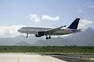 b-. 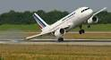 c.** 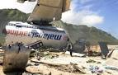

**2.** She put the bouquet of flowers in a vase:-

**a.** - 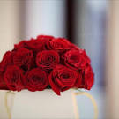 b- 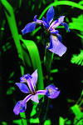 **c.**  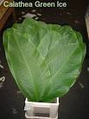

**B.** Read and complete: (3 points)

Tidy up - suitcases - checking in – cedar

1. We went to ……………………………………… forest in the mountains.

2. Alia…………………………………her bedroom.

3. Aunt Muna collected her…………………………….

**PART THREE**

Question Three: Focus on Language and Structures (7 points)

**A.** Choose the correct answer in the following sentences: (3 points)

1- Alia will------------- some sandwiches. a. make b. made c. making

2. She started to cry while they were-------- . a. check in b . checking in c. checks in 3. Sami -----------a book while I was walking in the market. a. buy b. bought c. buying

**B.** Use "**While ..?**" in the following: (4 points)

1. Ahmade / wait/ they/check in . .……………………………………………………………………………………………………………………………………..

2. they/talk/they /board the plane ………………………………………………………………………………………………………………………………………..…..

3. Ali/wake up/Sami/football/ playing/ …………………………………………………………………………………………………………………………

4. I /read book/ they/take off …………………………………………………………………………………………………………………………….……………

**PART FOUR**

Question Four: Focus on Writing (3 points)

**A.** Write about your : (3 points)

1-……………………………………………………………while I was helping Mum.

2-I started to study while I was………………………………………………..

3-…………………………………………..I was………………………………………………….

THE END

WITH MY BEST WISHES