

**English language Exam**

**Second Semester**

**First Exam**

**----------------School**

**Name:- Day:-**

**Class:-5th class Date:- / /2015**

**1-Read the following text carefully ,and answer the questions :-**

**Most of the food we eat comes from plants or animals. Farmers grow plants and keep animals to give us food .Meat comes from animals. Chickens us meat and eggs. Vegetables come from plants.**

**In the north of Jordan, some farmers grow olives .olives trees grow on the sides of the**

**mountains .**

**1- Where does most of our food come from?**

**--------------------------------------------------------------------------------------------------------------------------------------------------------------------------------------------------------------**

**2-Why do farmers grow plants and keep animals?**

**----------------------------------------------------------------------------------------------------------------------------------------------------------------------------------------------------.**

**3-Where do eggs come from ?**

**----------------------------------------------------------------------------------------------------------------------------------------------------------------------------------------------------.**

**4- Does meat come from a plant?**

**-----------------------------------------------------------------------------------------------------------------------------------------------------------------------------------------------------.**

**5- Where do the olive trees grow?**

**-----------------------------------------------------------------------------------------------------------------------------------------------------------------------------------------------------.**

**2-Choose the suitable item to complete of the following sentences :-**

**Put cook mix serve**

**You’re going to make cake:**

**1- First--------------------------------------------------.** 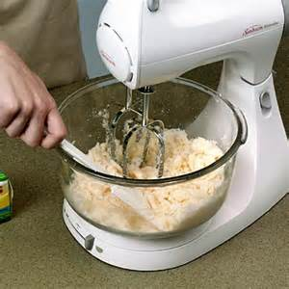

**2-Then--------------------------------------them.** 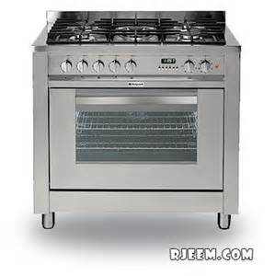

**3- Next,-----------some cheese in the saucepan.** 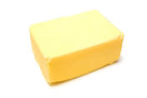

**4- Finally-----------on aplate.** 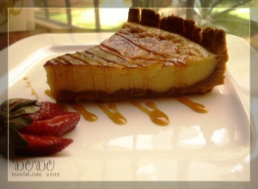

**3-Choose the answer from those given to complete each :**

**1-Ali is going to---------some flowers.**

**a- buy b- buying c- bought.**

**2- ----------there any sugar in the coffee?**

**a- Some b- Any c- Is .**

**3- There -------some bananas on the table.**

**a- are b- is c- was.**

**4- -------there any eggs in the box?**

**a-Is b- Are c- some.**

**5- There isn’t -------salt**

**a-are b –any c- some.**

**4-Mach please:**

**1- tastes delicious** 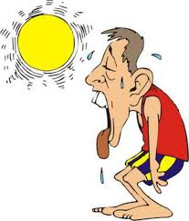

**2- looks beautiful** 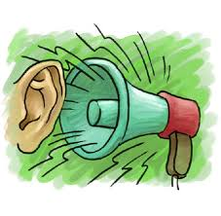

**3- sounds noisy** 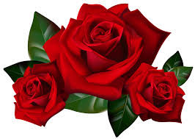

**4- feels hot** 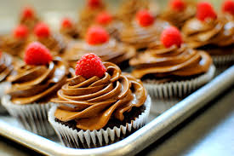

**5- smell good** 