Name:----------------- The First Month Exam For the Second Grade Qusour Co/Ed S.1

1. Write the numbers :

a. sixteen:--- b. twelve:---- c. nineteen:---- d. fifteen:---- e. twenty:----- f. seventeen:-----

2. Draw the hands:

Half past ten six o'clock eleven o'clock seven o'clock

**2. match between actions and pictures:**



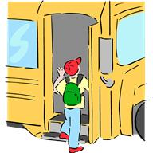

1. brush teeth

2. Have breakfast

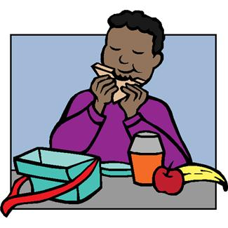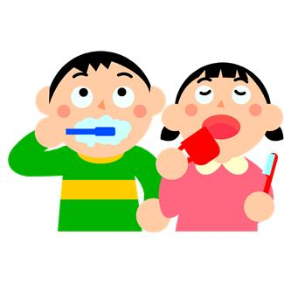3. Go to school

4. Get up

**3. Write the missing letters:**

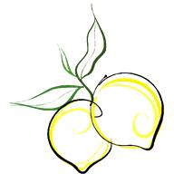

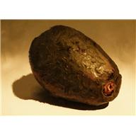

1. ---weet 2. ---live 3. ----ig 4. ---ates

Name:-----------------

Section The First Month Exam For the First Grade Qusour Co/Ed S.1

1. Match:

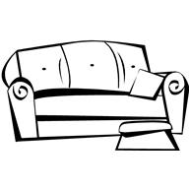

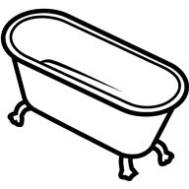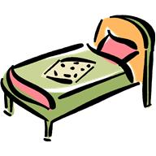

1. T.V 2. Box 3. Bed 4. Sofa 5. Bathtub

************************************************************

2. Circle:



1. On in under

2. On in under

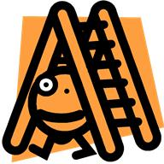

3. On in under

*********************************************************

3. Write the missing letters:



1.---indow



3. ---unny

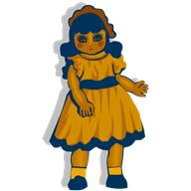

2. ----oll