**English language Exam**

**Second Semester**

**Second Exam**

**Name: Date: Class:- 3rd grade**

**1-Read the following text carefully ,and answer the questions :-(6 points)**

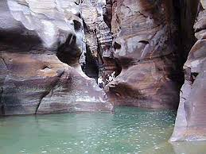

**The children are having their lunch in the mountains .They are drawing the animals in Wadi Mujib .A leopard is running .A wolf is sleeping .The goats are walking .frogs and fish are swimming in the river.**

**1- Where are the children having their lunch?**

**2- What are the children doing?**

**3-Aleopard is------------------ ( sleeping - running).**

**4- The goats are-----------------------.**

**5- Frogs are swimming in the river ( T F ).**

**6- The underline pronoun refer to------------.**

**2-look and write: (5 points)**

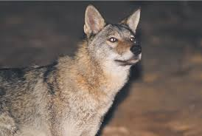 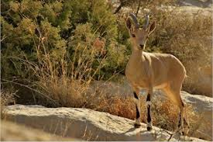 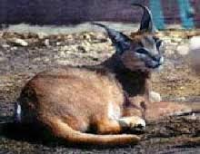 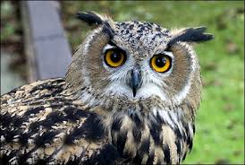 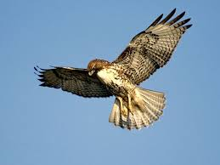

…………………………………………………………………………………………………………………………………………………………………………………………………………………………………………………………………………………………………………………………………………………………………………………………………………………………………………………………………………………………………………………………………………………………………….................................................................................................................................................................................................................................................................

**3-Complete the following sentences with correct verbs :-**

**1- Fish is ----------------------.(swim) in the sea.**

**2- An eagle is --------------------------( fly).**

**3- The cat is---------------------------( jump).**

**4- the boys are -------------------(read) . (4 points)**

**4- Choose the answer from those given to complete each sentence:**

**1- I------------------- help Mum.**

**a-must b- mustn’t**

**2- You------------------run.**

**a- must b- mustn’t**

**3-Are you listening to your teacher?**

**a- Yes, I am. b- No, I am not**

**4- Is the boy sleeping?**

**a- Yes, he is b- No, he isn’t**

**5- Are we eating ice- cream in the class?**

**a- Yes we are b- No we aren’t**

**(5 points)**

**5- Read and order:-**

**1- lot - mustn’t - eat - a – sweets- you- of**

………………………………………………………………………………………………………………………………………………………………………………………………………………………………………………………………………………………………………………………………………………………………………………………..................................................................................................................................................................................................................................................................................................................................................................................................................................................

**2-. you - must - tidy – bedroom - your.**

………………………………………………………………………………………………………………………………………………………………………………………………………………………………………………………………………………………………………………………………………………………………………………………................................................................................................................................................................................................................................................................................................................................................................................................................................................

**6- Read and mach :-**

**(2points)**

**1- What do you want to buy?**

**---------------------------------------------------------------------------------------------------**

**2- Do you want to drink juice?**

**(2 points)**

**7- Draw your favorite animal :-**

**(1 points)**