

**4th Grade**

**1st Test- 1st Semester**

**Name:-----------------------**

**ــــــــــــــــــــــــــــــــــــــــــــــــــــــــــــــــــــــــــــــــــــــــــــــــــــــــــــــــــــــــــــــــــــــــــــــــــ**

**Q1: Look and Match : ( 5 points )**

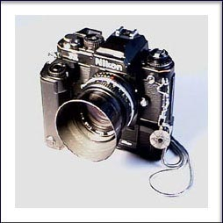  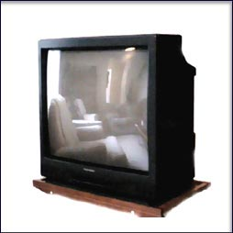 C:\Program Files\Microsoft Office\MEDIA\CAGCAT10\j0195384.wmf 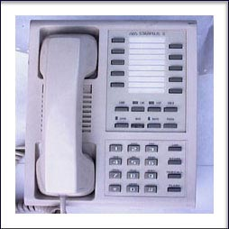

**T.V Computer Phone Letter Camera**

**ــــــــــــــــــــــــــــــــــــــــــــــــــــــــــــــــــــــــــــــــــــــــــــــــــــــــــــــــــــــــــــــــــــــــــــــــــ**

**Q2: Complete the sentences with the correct words from the box. ( 3 ps )**

|  |  |  |
| --- | --- | --- |
| **Usually** | **Always** | **Never** |

**1- Huda ----------------------plays football. (** **√√ )**

**2-Anas ----------------------does his homework every day. (√ )**

**3-Sami-----------------------writes stories daily. (x)**

**Q2 B : Complete the following sentences with suitable verb from the box. ( 6 points)**

|  |  |  |  |
| --- | --- | --- | --- |
| **Opened** | **L listened** | **watched** | **played** |

**1- Khalid ----------------the door yesterday.**

**2- Faris ---------------TV last night.**

**3- Mansour--------------tennis.**

**4- Khaldoun ------------------to music.**

**ـــــــــــــــــــــــــــــــــــــــــــــــــــــــــــــــــــــــــــــــــــــــــــــــــــــــــــــــــــــــــــــــــــــــــــــــــ**

**Q3- Punctuate the following sentences. ( 2 points )**

**1- ali likes going to amman**

**…………………………………………………………………………..**

**2- what are you doing**

**……………………………………………………………………….**

**Q4: Match the following questions with answers. ( 4 points )**

**1-What is your name? a- I am 10 years old**

**2-How old are you? b-I am fine thank you**

**3-What are you good at? c- My name is Hamad**

**4- How are you? d- I am good at English**

**Good luck**

**…………………..**

**With my best wishes**