

**The Ministry of Education**

**The Education Directorate of ------------**

**Final Exam- Second Term**

**2021/2022**

**Class: 2nd Grade**   **(Action Pack 2)** **Material: English Language**

**Date:**

**Time: One hour.**

**Name: .......................................................................................................................................Section :(..................)**

**PART ONE**

Question One**:** Reading Comprehension (7.5 points)

-Read the following text **carefully** and then answer all the questions below:

My uncle is tall. He's got brown eyes and short grey hair. My aunt's short ,she's got brown eyes and black hair .

**1.** My uncle is---------- a-short b- tall (1 points)

**2.** He's got brown eyes. ( T - F) (1.5 points)

..

**3.**My aunt's got, ------------- eyes and-------------------- hair. (3 points

**4.** I've got ---------------eyes. a- black b- brown c-blue (2 points)

Question Two: Focus on Vocabulary (5 points)

A. Look, match and write: (5 points)

**Cycling - reading - running - playing tennis - drawing**

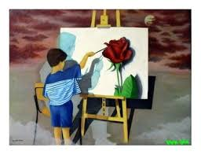 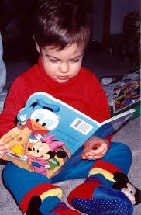 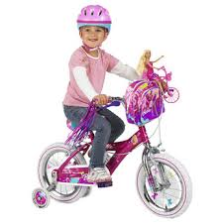

----------------------------------- ---------------------------------- -----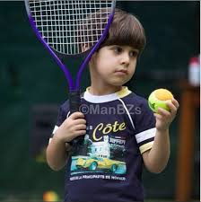----------------------------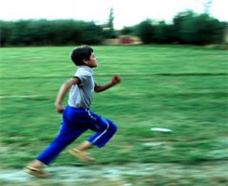

Question Three: Focus on Language and Structures (7.5 points)

**A.** Choose the correct answer in the following sentences: (5 points)

1. Is it a ball 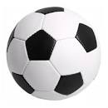?. A-Yes it is b-No it isn't c- No there isn't

2. There-----------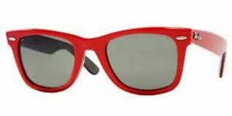 sunglasses. a- is b- are c- ?

3. ------------- a hat ? a-Is there b- Are there c- Is it

4- Is he go to school? a- yes he is b- N o he isn't



5- I-------------breakfast. a- has b- have

**B.** count and write: - (2,5 points)

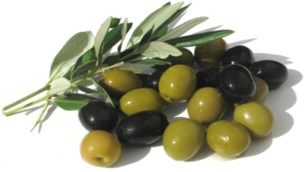

------------------------------------------------------------- ------------------------------------------------------------

**PART FOUR**

Question Four: Focus on Writing (3 points)

**A**. Spell the following words: (3points)

1. Mazen.--------------------

2- Hammad.---------------------

3- Salem.------------------------

**B.** write please : (2 points)