## The Hashemite Kingdom of Jordan Ministry of Education

25

**The first semester exam of the year....../…..**

Al-Nahdha school Subject: English

Class:Grade2 Time: One hour

Student's name..……………………................... Date………./ /

**Mention the name of each selected animal:(3marks)**

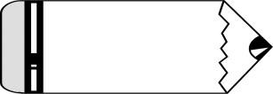

# tiger

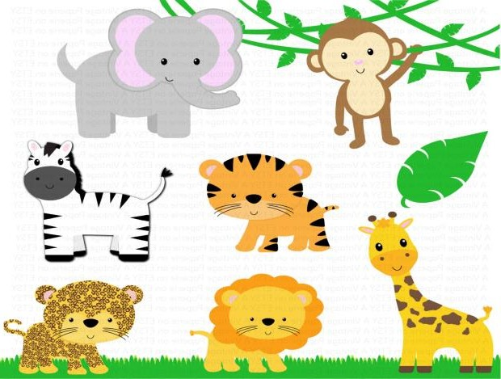

elephant



lion



bear

## A:Completethegapswiththecorrectdayoftheweek:(4marks)

Sunday…...…….…..Tuesday…..…..……..

…..…..……..Friday…....………..

## B:Match each expression with the correct picture:(3marks)

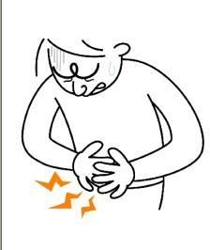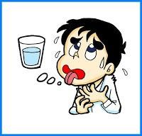

I'm thirsty I'm ill I've got a stomach ache

1

## Fill in the blanks with the correct adjectives:(3marks)



old



young



big

 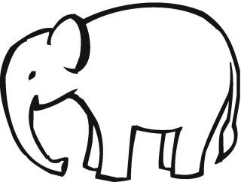 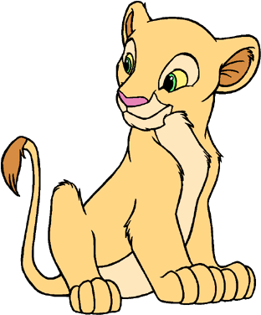

….………… ……………… ……………...

## B:Reorder the following tters to form meaning full words:(2marks)

eadhheca ………........………………….

ooachtthe……….….......…………….…

## Choose the correct answer between the brackets:(4marks)

1. Can **they**…………..?(**swim**/**swims**)
2. Where do **you**…………..?(**lives**/**live**)
3. **She**………….in Amman.(**live**/**lives**)
4. …………...**you** got a stomach ache?(**Has**/**Have**)

## Circle the correct answer:(6marks)

1. **Is** it a park ?Yes,it……..
   1. is b. was c. Is
2. **She** a near ache.
   1. Have got b. has get c. has got 3.No,they…………..
   2. can b. could c.can't
3. **Is** it a park ?Yes,………...
   1. is b. isit c. itis
4. does your mother live?
   1. Where b .Do c. Does
5. bear**s**.

# They're b.It's c.Isit

2

TEACHER: ALA’TWAIT