mark

**The Ministry of Education 25**

**The Education Directorate of---------**

**Second Exam first Term**

**Class: third Grade**   **(Action Pack 3)** **Language** **English**

**Date:**

**Name: ...................................................................................................................**

_________________________________________________________________________________________

**PART ONE**

Question One: Reading Comprehension (5 points)

-Read the following text **carefully** and then answer all the questions below:

I like my school. Islamic Education and English are my favourite lessons. I visit my grandparents on Friday and Saturday.

My father is a doctor. He works in a hospital in Aqaba.

My mother is a teacher. She works in a school in Aqaba.

Best wishes,

Majeda

**1- Majeda's favourite lesson is ……………………………**

**a-Arabic b- Islamic** **Education c- Maths**

**2-When does Majeda visit her grandparent?**

**........................................................................................................................................................................**

**3- Majeda's father is………………………………………………………………………………………**

**4-What does Majeda's mother do?**

**........................................................................................................................................................................**

**5-Does Majeda's mother work in a hospital? a- Yes, she does b-No, she doesn't**

.**PART TWO**

Question Two: Focus on Vocabulary (4 points)

**A-Read and match :-( point)**

**1-Does Ali like football? a- He's a pilot**

**2- Does your mum a teacher b-Yes, we do**

**3- Do we have Moths on Monday c- No, he doesn't**

**4- What does Ali do? D- Yes, she does**

**B.** Read and complete: - (3points)

- in - under - next to 0n

1. the snail is-------------- the box. 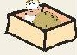

2. the snail is-------------- the box. 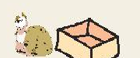

3. the snail is-------------- the box. 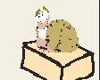

**PART THREE**

Question Three: Focus on Language and Structures (7 points)

**A.** Choose the correct answer in the following sentences: ( 5points)

|  |  |  |  |  |
| --- | --- | --- | --- | --- |
| **Sunny** | **winter** | **ride** | **have** | **work** |

**1-We.............................. Science at nine o'clock.**

**2-Does she ...................... in a hospital?**

**3-My favourite season is .........................**

**4-In spring, I ……………….... my bike.**

**5-Jordan is hot and ......................... in summer.**

**B--Complete the following question with (Do) or (Does)**:- (2points)

**A-.........you like playing chess?**

**B-Where...........she work?**

**C-When ......... he arrive?**

**D-........ they work in a hospital**?

**ART FOUR**

Question Four: Focus on Writing (4 points)

1**-Write the correct time:**

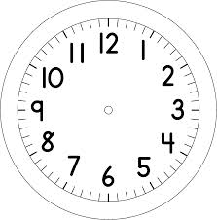

**2) Copy and complete with the punctuation: (capitals, . or ?): (2 points)**

**1. Ibrahim is a chef .He works in a restaurant.**

**2- We have English on Sunday.**

**2) Order the sentences: (2 pts)**

THE END WITH MY BEST WISHES