

**Department of Education / Zarqa Area**

English Language Second Exam

Second Semester /

School : **-------------------------------------------- Date :**

Name : ------------------------------------------------ 3rd Grade ( )

**QUESTION ONE Read and answer ( 7 points )**

**The children are having their lunch in the mountains . Samira is drawing the animals in Wadi Mujib . A leopard running . A wolf is sleeping . The goats are walking . Frogs and fish are swimming in the river ,**

**Abla**

**A ) Answer : ( 3 points )**

**1 – Where are the children having their lunch ?**

**---------------------------------------------------------------------------**

**2 - Are the fish swimming in the river ?**

**---------------------------------------------------------------------------**

**3 - Is the leopard sleeping ?**

**---------------------------------------------------------------------------**

**B ) Complete : ( 2 points )**

**1 – Frogs and --------------------- are swimming in the river .**

**2 - Samira is drawing the ----------------------- in Wadi Mujib .**

**C ) Put tick ( ) or cross ( ) ( 2 points )**

**1 - A wolf is sleeping . ( )**

**2 – The goats are walking . ( )**

**QUESTION TWO Match the questions with the right answers ( 4 points )**

|  |  |
| --- | --- |
| 1. **Happy Mother’s Day , Mum !** | **A – I want to buy a book .** |
| 1. **What do you want to buy ?** | **B - Thank you .** |
| 1. **Are they running ?** | **C - Yes . I do . Let’s make a big card** |
| 1. **Do you want to make a card ?** | **D - Yes , they are .** |

**Answers : 1 --------------- 2 ----------------- 3 ----------------- 4 ----------------**

**QUESTION THREE order and write ( 4 points )**

**wolf December goat April**

|  |  |
| --- | --- |
| Animals | Months |
|  |  |
|  |  |

**QUESTION FOUR Choose the right answer ( 5 points )**

**1 - The summer holiday starts in ------------------------- .**

1. **June b - September c - March**

**2 - We give presents to our mothers in ----------------------- .**

1. **April b - February c - March**

**3 - I can hear with my two --------------------------- .**

1. **eyes b - ears c - arms**

**4 - ----------------- the eagles flying ?**

1. **Is b - Are c - Does**

**5 - ----------------- the cat jumping ?**

1. **Is b - Are c - Does**

**----------------------------------------------------------------------------------------------------------**

**QUESTION FIVE Look and write ( 3 points )**

|  |  |  |  |  |  |
| --- | --- | --- | --- | --- | --- |
| **card** | **owl** | **leopard** | **frog** | **goat** | **scarf** |

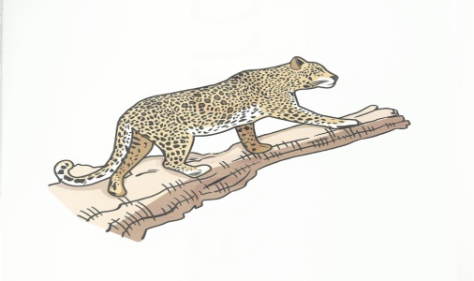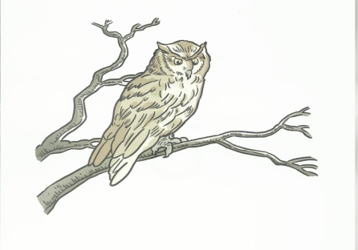

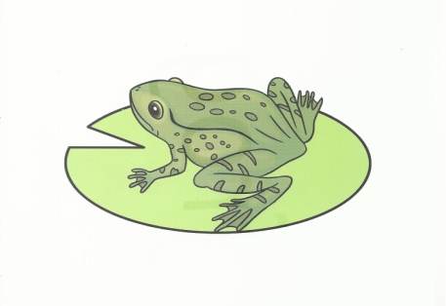***----------------------- -------------------------- -----------------------***

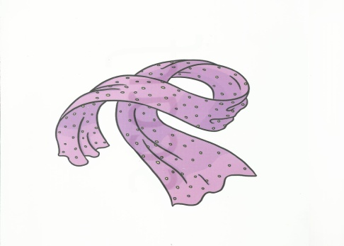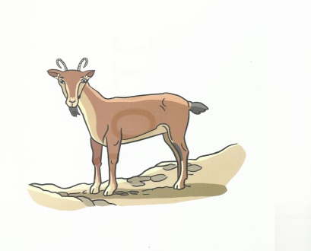

***----------------------- --------------------- -----------------------***

**QUESTION SIX Read , look and answer ( 2 points )**

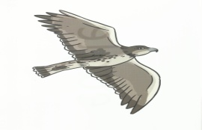***1 ) Is the eagle flying ? -------------------------***

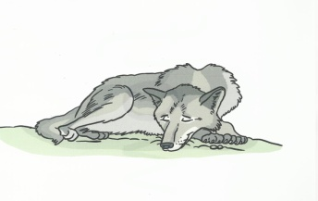

***2 ) Is the wolf running ?----------------------***

Good Luck

Teacher Emad Sbeihat