**Name: English Exam( 1) Al Qusour Co Ed S/2 4th grade**

**Mrs.Marwa Omar**

**Dear Laila and Ali**

**We’re going to Aqaba.Dad is driving .We are driving through the mountains. We are visiting Hammamat Main .There is a very big waterfall**

**Samira and Kareem**

***Read and answer:*** ***Reading /****4*

1. *1.The family is travelling to Aqaba by* ***car / plane***

*There* ***is / isn’t***  *waterfall in**Hammamat Main*

*3.Who writes the letter?----------------------------------------*

*4- The underlined pronoun* **We’re is : ------- -------**

***Choose /2 Speaking / 6***

***1.***  Ali never ------------- T.V

***a- watch b- watches c- watching***

***2-*** *This is Laila. ------- is a new pupi****l***

***t a- He b-She c- i***

***3-****We ---------- do our homewor****k***

***a- never b- sometimes c always***

***4- --------*** *Kareem like playing football****?***

***a- Do b- Does c- Doing***

***\*****Are you --------- a book****?***

***a- read b- reads c- reading***

***\**** *Is Kareem playing tennis****?***

***No, He***

***Answer Qs: /4***

***1-****Are the dolphins jumping****? ( ) No , he isn’t***

***2-****Are you playing the piano****? ( ) No, it isn’t***

***3-****Is Ahmad sailing?* ***( ) Yes , they are***

***4-****Is the cat sleeping****? ( ) Yes , I’m***

***Write the words Writing / 6***

***[* handball, volleyball, laboratory, pupil ,monitor ]**

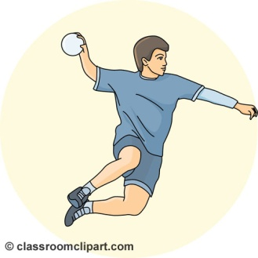





**

*Punctuate*

***issa is helping ahmad***

***she is doing a project about amman***

*Listen and tick****: /3 Listening / 6***

***Thursday-this [ ] computer - keyboard [ ] children-shopping [ ]***

***Good luck***