**Second Semester 2024 / 2025**

**English Exam / Grade 1**

**Name : ………………………...**

**_______________________________________________________________________________________**

**Read and match**

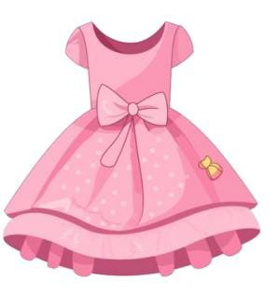 **socks**

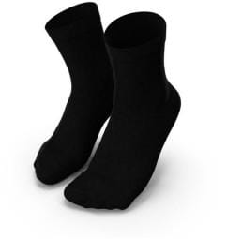 **dress**

**jeans** 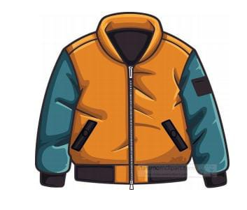

**Jacket** 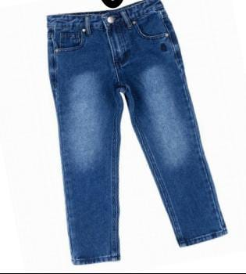

**Look ,read and circle:**

**Where's my jacket?** 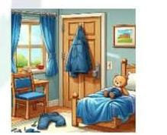

**Its on the floor / door**

**Where's my jeans ?**

**Its on the chair /floor**

**Circle the "N"sound**

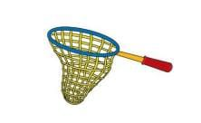 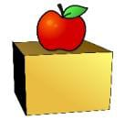 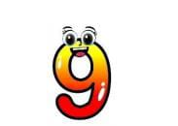

**Circle the "J" sound**

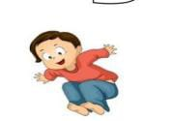 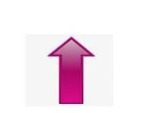 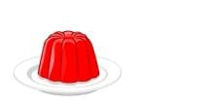

**Write capital letter:**

** o  u**

** n**

**2**

**Aisha Bint Abi Baker School**

**Second English exam for the 2nd semester of 2024/2025**

**Day: Monday Grade 1 ( )**

**Date: 14/4/2025 Name: ----------------------**

**Q.1: Write the word under the picture :(4 Points)**

|  |  |  |  |
| --- | --- | --- | --- |
| **dress** | **socks** | **jumper** | **skirt** |

**----------------- -------------- -------------- ---------------**

**on**

**in**

**Q.2: Fill in the blanks :( 3 points)**

**under**

**---------- ---------- -----------**

**Q.3: Write the missing letter: (3Points)**

**------- am -------mbrella -------- range**

**Good Luck**

**Teachers:NamarqAlshweikh**

**AseelAlnawaiseh**