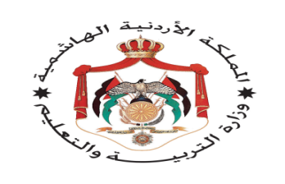

**English language Exam**

**Second Semester**

**First Exam**

**----------------School**

**Name:- Day:-**

**Class:-4th Grade Date:- / /2015**

**1-Read the following text carefully ,and answer the questions :- (5 points)**

**Dear Ali,**

**My favorite museum is the Children’s Museum. Its in Al-Hussein National Park in Amman .It’s the biggest children museum in the Middle East. There is a library, a theater a restaurant and a shop. My favourite room is the planetarium. Come and fun!**

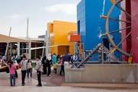

**1- Where is the Children’s Museum?**

**---------------------------------------------------------------------------------------------------.**

**2-Where can you read books in the museum?**

**-------------------------------------------------------------------------------------------------.**

**3-Where can you learn about the planet and the stars ?**

**-------------------------------------------------------------------------------------------------.**

**4- Where can you buy food?**

**--------------------------------------------------------------------------------------------------.**

**5- Have you ever visited the Children’s Museum?**

**------------------------------------------------------------------------------------------------.**

**2-Choose the suitable item to complete of the following sentences :-**

**(5 points)**

**Fountain - river - forest - stadium - stage**

**1-I can swim in the-------------.** 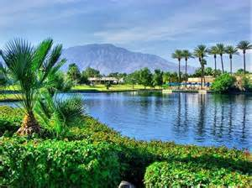

**2-In th past there wasn’t a-----------------------.** 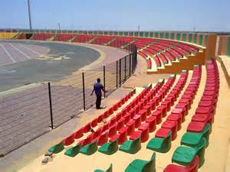

**3-There is a----------------------------in the Children’s Museum.** 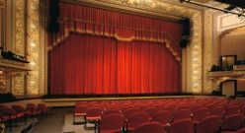

**4- Wild animals live in ---------------.** 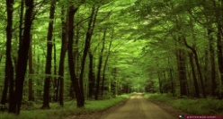

**5- There was a big------------------.** 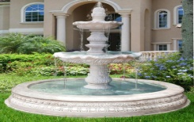

**3-Choose the answer from those given to complete each \sentences :- (5 points)**

**1-On the evening I-------------at the school.**

**a- am b- was c- wasn’t .**

**2- The restaurants-----------------here in the past.**

**a- was b- are c- aren’t.**

**3- The Roman Theater ------------- here in the past.**

**a- is b- was c- are**

**4- Sami is --------------Sameer.**

**a-tall b- taller than c- tallest**

**5- Jupiter is the ------------- planet.**

**a-big b –bigger than c- biggest**

**4-Read and circle (Yes) or(No) (3 points)**

**1- Amman was called “Philadelphia “in the past. Yes/No**

**2- The sun is a planet. Yes/No**

**3- Jerash is the biggest city in Jordan. Yes/No**

**5-Answer the following questions:- (1 point)**

1. **Where do you live?**
2. **Which is the fastest animal?**

**6-copy please: :- (1 point)**

**In the past there were big forest in Jordan.**

**----------------------------------------------------------------------------------------------------------------------------------------------------------------------------------------------------------------------------------------------------------------------------------------------------------------------------------------------------** 