English Test / First Semester
Grade 2
Name :………………….. Section : ……
_____________________________________________________________________________
Q.1 Look and circle :- ( 4 points )
 | kite
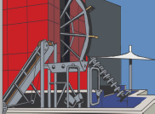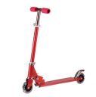 | museum
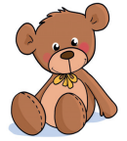 | wall climbing
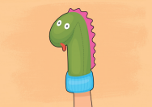 | puppet

________________________________________________________________________________________________________
Q.2Read and write :- ( 4 points )

Sami Laila Tom poll

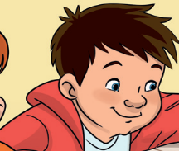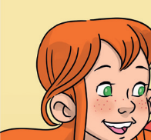

________________________________________________________________________________________________________

Q.3 Choose the correct answer :- ( 6 points )
1.Hello! I’m........................ . (Tom / polly)
2. 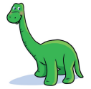How manydinosaur ? ( four / five )
3. What colour is the orange? (brown / orange )
4.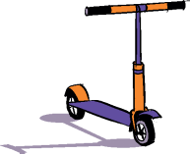What's this ? It's .................... ( scoter / action figure )

5. 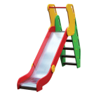Is it a slide?( Yes, it is / No, it isn't )

6. It’s .......plane .( a / an )

Q.4 Write the missing letters :- ( 4 points )

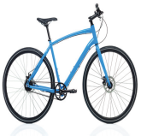9
b...k... c...k...n...n... g...t...

Q.5 Complete the numbers:- ( 2 points )
 | two |  | four |  | six
___________________________________________________________
Good Luck

