2nd grade 1st exam first semester Name:-------------------
1)LOOK and Match: -


1-action figure

2-doll

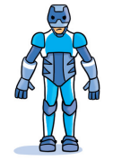
3-slide

**********************************************************************************
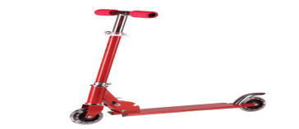
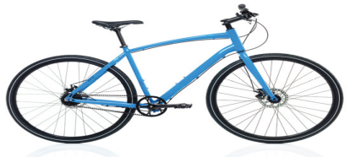
2)Read and circle:-

1)Is it a bike? 2)Is it a swing?
Yes, it is Yes, it is.
No, it isn’t No, it isn't.

******************************************************************************
3)Choose the correct phonic( i-e a-e)

5
1) Pl—n— 2) F—v—
4) How many balloons:-


----------------------------
5)colour:-

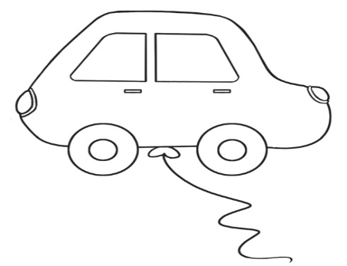

Orange purple

Best wishes

