2nd semester
Test pattern
Name:
Question 1: Look, read and answer the questions.
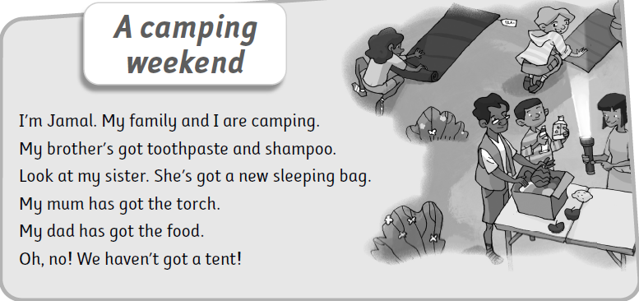

Find out:
Noun: .. ..
Verb: ... .. ..
An adjective: .. ..

Circle the correct answer.

- Has she got sunscreen? ________, she________.

- Has he got a torch? ________, he________.
- Has she got a new sleeping bag? ________, she________.
- Has he got the food? ________, he________.

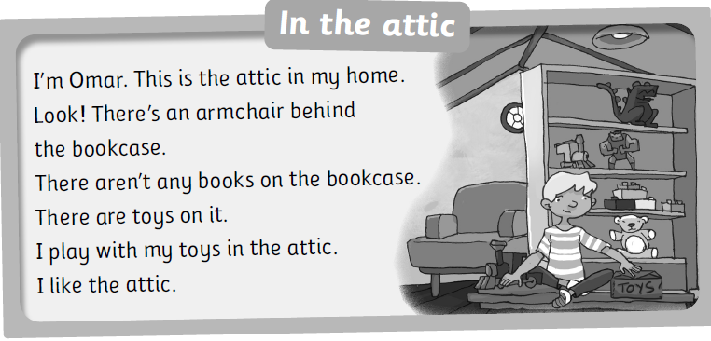

Find out:
Noun: .. ..
Verb: ... .. ..
Preposition: .. ..

Circle the correct answer.
1. Omar is in the_____________.
a. garage b. attic c. bedroom
2. _____________a sofa in the attic.
a. There isnt b. Theres c. There arent
3. The armchair is_____________the bookcase.
a. in front of b. behind c. opposite
4. _____________any books on the bookcase.
a. There are b. There isnt c. There arent
Question 2: Look, choose and write.
vegetables and meat | television | mountains | bookcase
fireplace | armchair | toothpaste | sunscreen

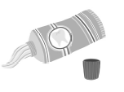 |  | 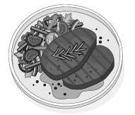
 |  |  | 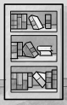

Question 3: Circle the correct answer.

- I ______ got a pencil. ✏ ( have got / has got )
- ______ he got a bag? 🎒 ( have got / has got )
- She ______ got a dog. 🐶 (X) ( haven’t got / hasn’t got )
- ___________a television. ( There are / There is )
- ___________bookcases. ( There are / There is )
- ___________clock behind opposite the door.
( There isnt a / There arent any )


Question 4: A: Listen and order. Then write.
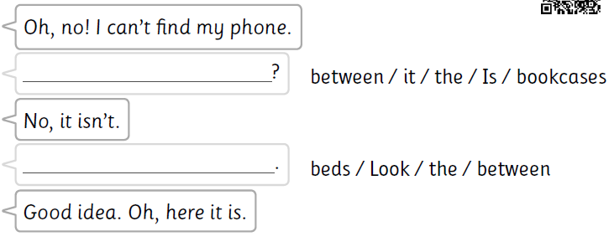

Question 4: A: Listen and write.
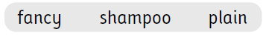

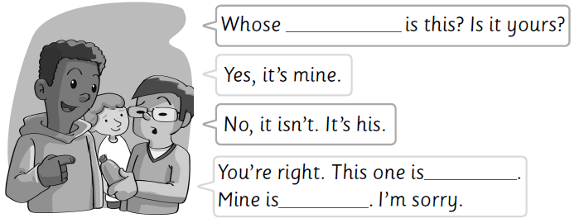

B: Listen and write.

 |  |  | 
_ _eese | _ _eep | _ _ock | _ _ag

Question 5: Complete using the tables.
chair | attic | armchair
window | bookcase | book

toys | windows | armchairs
chairs | bookcases | books

This is the_____________ in my home.
Theres a______________.
There isnt a______________.
There are______________.
There arent any______________.

new | clean | a toothpaste | a sleeping bag
old | dirty | a shampoo | a torch
plain | fancy | a tent | a sunscreen

Ive got_____________.
I havent got_____________.
My friend has got_____________.
My friend hasnt got_____________.

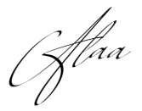

Second English Language Exam
2nd semester
Name: Date: / 4 /
Time: One class Grade 3: A / B / C / D
Question No. | 1 | 2 | 3 | 4 | 5 | Number of questions | 5
Mark of a question | 3.5 | 4 | 2.5 | 3 | 2 | Total marks | 15
Students mark |  |  |  |  |  | Total of student's marks

Question 1: Look, read and answer the questions. (3.5 marks)

- Find out: (1.5)
Noun: .. ..
Verb: ... .. ..
Preposition: .. ..

B. Circle the correct answer. (2)
1. Omar is in the_____________.
a. garage b. attic c. bedroom
2. _____________a sofa in the attic.
a. There isnt b. Theres c. There arent
3. The armchair is_____________the bookcase.
a. in front of b. behind c. opposite
4. _____________any books on the bookcase.
a. There are b. There isnt c. There arent

Question 2: Look, choose and write. (4 marks)

grill | logs | mirror | clock
fire | sofa | torch | sleeping bag

 | 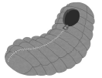 |  | 
 |  | 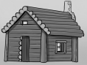

Question 3: Circle the correct answer. (2.5 marks)

1. He a big house. ( have got / has got )
2. I . a new dress. ( havent got / hasnt got )
3. armchairs. ( There are / There is )
4. ..a sofa. ( There is / There are )
5. ..windows next to behind the bed.
( There isnt a / There arent any )

Question 4: A: Listen and order. Then write. (1 mark)

B: Listen and write. (2 marks)

_ _ip _ _op | _ _op | _ _iff | _ _air

Question 5: Complete using the table. (2 marks)

chair | attic | armchair
window | bookcase | book

toys | windows | armchairs
chairs | bookcases | books

This is the_____________ in my home.
Theres a______________.
There isnt a______________.
There are______________.
There arent any______________.

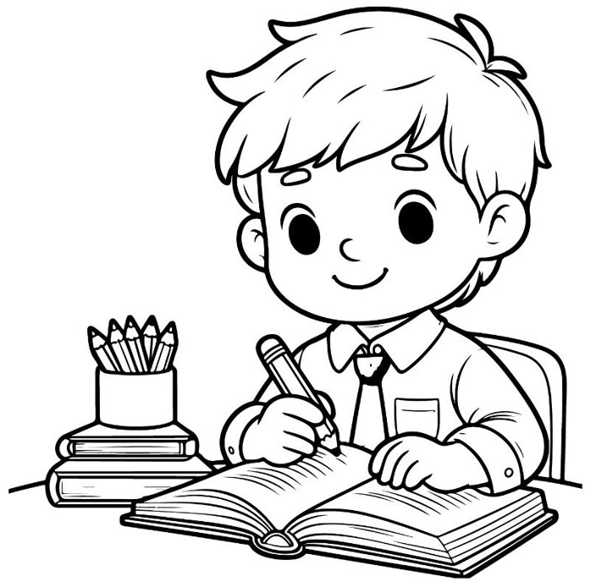

Good luck
my lovely students


