
Ministry of Education / Qasaba Amman Directorate
First semeste
Second English Exam 5-2022026
Student’s name :…………………………………………………………………… 2nd grade A
Q1: Read the text and answer the following questions: - (5m)
1_What is the name of the boy ? ……………………..………….…………………
2_ Where is the school ? ………………………………………………
3_ Circle : - The playground is ……………………….
a- big b- small
4_ find out from the text :
A_ Noun : ………….……….. B_ preposition : ….................
__________________________________________________________________________________________
Q2 A: Fill in the blanks with the suitable word : (5 m)

[• crayon • cupboard • ruler • eraser • scissors ]
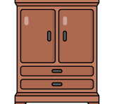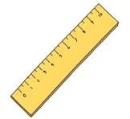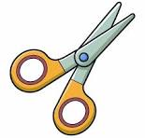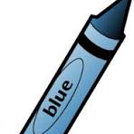

1 ………………..……….……… 2 …………………………… 3……………………… 4………………………………. 5 ……………………..
Q3: Choose the correct answer : ( 8 m)
1_ This is …………………………… A_ pen B_ pens
_____________________________________________________________________________
2_ These are …………………………… A_ ball B_ balls
_____________________________________________________________________________
3_ This ………………………… a book A_ is B_ are
_____________________________________________________________________________
4_ These ……………………… bags A_ is B_ are
__________________________________________________________________________________________
Q4: Write the missing letters : [ sh _ ch ] (4m)

1- ______ air 2- _____ elf 3- _______ ick 4- _____ op
___________________________________________________________________
Q5: Write the correct preposition in the blank : ( 3 m)
{( in _ on _ under )}
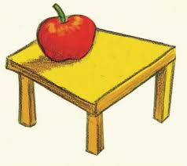
1_ The apple is ……………………. the table .

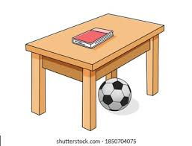
2_ The ball is …………………………. the table .

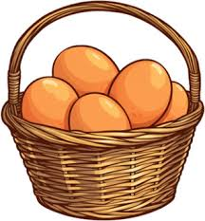 3_ The eggs are …………………….. the basket .

English Test / First Semester
Grade 2
Name :………………….. Section : ……
Q.1 Look and circle :- ( 4 points
crayon
computer
cupboard
eraser
___________________________________________________________
Q.2 Read and write :- ( 4 points )

on in under

Q.3 Choose the correct answer :- ( 6 points )

1. How many scissors can you see? ( two / seven )
2. ........................my green pencil sharpener. ( This is / These are )

3.Where’s the teddy? It’s .................the bag. ( in / on / under )

4. This is .....................( playground / library )

5. Is it the hall? ( Yes / No )

6. What colour is the scooter? ( brown / seven )

Q.4 Write the missing letters :- ( 6 points )
...air ...elf ...ain ...op ...ick ...ell
___________________________________________________________

Good luck

English Test / First Semester
Grade 2
Name :………………….. Section : ……
Q.1 Look and circle :- ( 4 points )
 | playground
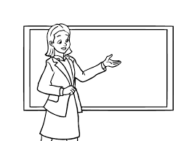 | pencil sharpener
 | school
 | desk
Q.2 Read and write :- ( 4 points )
shell chin chick scissors

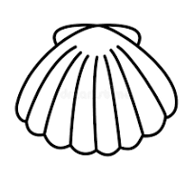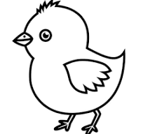

Q.3 Choose the correct answer :- ( 6 points )

1.How many can you see? ( four / five )

2....................... my pink scissors .( This is / These are )

3.Where’s the pencil? It’s............. the desk.( in / on / under )

4.This is ..................... ( hall / classroom )

5. Is it the playground? ( Yes / No )

6. How many cars can you see? ( two / blue )

Q. 4 Write the missing letters :- ( 6 points )
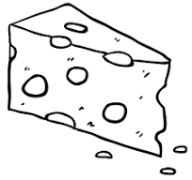

...ell ...irt ...air ...elf ...op ...eese

___________________________________________________________

Good Luck

_____20

English Test / First Semester
Grade 2
Name :………………….. Section : ……
Q.1 Look and circle :- ( 4 points)
shelf
scissors
Pencil case
computer

Q.2Read and write :- ( 4 points )

school classroom park library

Q. 3 Choose the correct answer :- ( 6 points )

1. How many chair can you see? ( eight / three )

2.......................my blue bags. ( This is / These are )

3.Where’s the pencil? It’s................ the desk. .( in / on / under )

4.This is ..................... ( playground / library )

5. Is it the library? ( Yes / No )

6. What colour is the scooter? ( yellow / ten )

Q. 4 Write the missing letters :- ( 4 points )

...elf ...air ..ell ...ick ...irt ...op

___________________________________________________________________
Good Luck

