Al frasah private school
Second semester – 2nd English exam
Name:____________________________
__________________________________________________________
Q1) look and match:
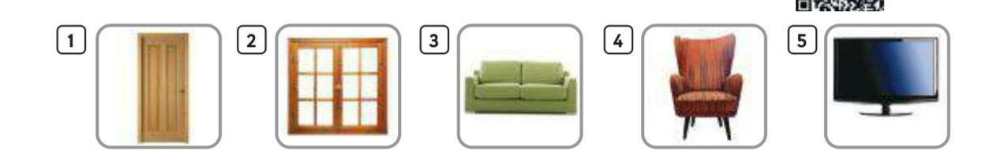

window
door
armchair
sofa
Television
______________________________
Q2) Write the opposite adjective:
Clean wet old
new
dry
dirty
_____________________________________________________________________________________
Q3) Write n the blank:
Has got | Have got
1_ Ali _________________ a new car.
2- They ___________________ a fancy kite.
3- she _______________ an old car.
4- Asma and Laila _____________ a new bags.
________________________________________________________
Q4) Listen and write:
(Cl _sl_fl )
____eep ___ag ___iff ___ean ___ug
__________________________________________________________
Q5) Translate into Arabic:
His car her car
_____________ ______________

GOOD LUCK

