First Semester 2024 / 2025
English Exam / Grade 1
Name : ………………………... Section : ………
_______________________________________________________________________________________
Read and match ( 4 points )
legs
arms
face
head

Look and write ( 3 points )
hair hand feet

Read and circle :- (1 points )
Hello! My name’s Hala. I’m ( five / four) 
_____________________________________________________________________
Circle the "h " sound (3 points )
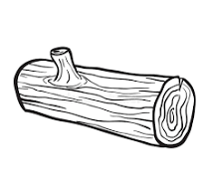
____________________________________________________________________
Circle the odd one out. (1 points )
_____________________________________________________________________
Copy Hh L L body (3 points )
____________________________________________________________________
L h f
…eet …and …eg
____________________________________________________________________
Count and write the number (2 points )

First Semester 2024 / 2025
English Exam / Grade 1
Name : ………………………... Section : ………
_____________________________________________________________________
Read and match ( 4 points )
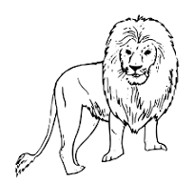 hat
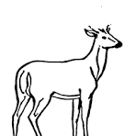 leaf
lion 
goat
_____________________________________________________________________
Look and write ( 3 points )
gate face log

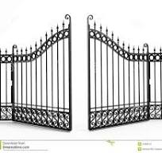

Read and circle :- ( 1 points )


Hello! My name’s ( Hala / bill )
_____________________________________________________________________
Circle the "g " sound ( 3 points )
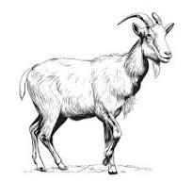 4 
____________________________________________________________________
Circle the odd one out. ( 1 points )
_____________________________________________________________________
Copy Gg Ff Lion (3 points )
____________________________________________________________________
g h L
….ate …ead …ion
____________________________________________________________________
h / L h / L

First Semester 2024 / 2025
English Exam / Grade 1
Name : ………………………... Section : ………
_______________________________________________________________________________________
Read and match ( 4 points )
gate
goat
hand
girl
_____________________________________________________________________
Look and write ( 3 points )
four Lion five

5 4


Read and circle :- (1 points )
Who’s this? This is my sister/ brother.
_____________________________________________________________________
Circle the "L " sound (3 points )
____________________________________________________________________
Match the capital letters with small letters :- (4 points )
H f
L g
G L
F h
_____________________________________________________________________
Copy Gg Ff Log (3 points )
____________________________________________________________________
L h f
…eet …and …eg
___________________________________________________________
h / L h / L h / L
First Semester 2024 / 2025
English Exam / Grade 1
Name : ………………………... Section : ………
_______________________________________________________________________________________
Look and circle :- ( 4 points )
legs
log
face
gate

_____________________________________________________________________
Look and write ( 2 points )

brother | sister | dad
Who’s this? This is my…………………………….

Who’s this? This is my…………………………….

Look and circle :-
- 4
h L f g h L g h f g
____________________________________________________________________

Circle the "f " sound (3 points )
____________________________________________________________
Copy Hh L L girl (3 points )
____________________________________________________________________
Write the missing sound :-

L h f
…eet …and …eg

____________________________________________________________________
Good Luck

